**Name: Muhammad Umair Faiz**

**Roll/No: 2k20/ITE/94**

#### Submitted to

#### Sir Kamran Dahri

**\*Note:** Here I’ve create an account in Oracle Database using **SQL Plus** named ***Umair Faiz***

➢ In **Umair faiz** account I’ve created a table with specification, see below.

• Table name **Course** with 2 columns **Course_id** & **Course_name.**

**\*Note:** Also two more Accounts I’ve created **Bee** & **Chris.**

**\*Note:** To **Bee** I’ve granted some special permissions

Query: **grant alter, delete, insert, select, update on course to bee;**

**\*Note:** To **Chris** I’ve granted only view permissions Query: **grant select on course to Chris;**

Now I’m trying to view,

# select * from course;

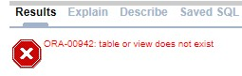

Output:

## From Bee: =>



**From Chris:** =>

# select * from Umair Faiz.course;

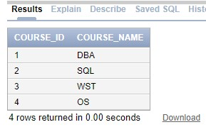

Output:

**From Bee:**

=>

**From Chris:**

=>

# update Umair faiz.course set course_name = 'INTRO TO SQL' where course_name = 'SQL';

Output:

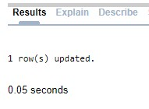

## From Bee: =>

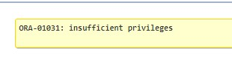

**From Chris:** =>

# create index ind_course_name on alex.course (course_name);



Output:

**From Bee:**

=>



**From Chris:**

=>

**Practice Questions:**

1. **Create two roles:** 
   1. Teachers
   2. Students

Queries: **create role teachers;**

Queries: **create role students;**

1. **Create Following accounts** 
   1. **Teachers** 
      1. **UserName**: Zia

**Password**: 123 ii. **UserName**: Arshad

**Password**: 1234 iii. **UserName**: Sara

**Password**: 12345

* 1. **Students** 
     1. **Username**: Fahad

**Password**: 1234 ii. **Username**: Nida

**Password**: 12345 iii. **Username**: Ali

**Password**: 123456 iv. **Username**: Khan

**Password**: 1234567

**Teachers Accounts:**

Queries:

**create user Zia identified by 123; default tablespace users temporary tablespace temp quota unlimited on users;**

Queries

**create user Arshad identified by**

**1234; default tablespace users temporary tablespace temp quota unlimited on users;**

Queries

**create user Sara identified by 12345;**

**default tablespace users temporary tablespace temp quota unlimited on users;**

**Students Accounts:**

Queries:

**create user Fahad identified by 1234;**

**default tablespace users temporary tablespace temp quota unlimited on users;**

Queries:

**create user Nida identified by 12345;**

**default tablespace users temporary tablespace temp quota unlimited on users;**

Queries:

**create user Ali identified by 123456;**

**default tablespace users temporary tablespace temp quota unlimited on users;**

Queries:

**create user Khan identified by 1234567;**

**default tablespace users temporary tablespace temp quota unlimited on users;**

**iii. Grant below mentioned permissions to roles**

1. **Teachers**

* 1. grant alter session
  2. create session
  3. create database link iv. create table
  4. create sequence
  5. create synonym vii. create view

1. **Students** 
   1. grant alter session
   2. create session iii. create database link

## Granting Permission to Teachers Role

Queries:

**grant alter session, create session, create database link, create table, create sequence, create synonym, create view to teachers;**

## Granting Permission to Students Role

Queries:

**grant alter session, create session, create database link to students;**

**iv. Assigning Roles to Users**

1. Assign **Teachers** role to following users
   1. Zia
   2. Arshad
   3. Sara
2. Assign **Students** role to following users
   1. Fahad
   2. Nida
   3. Ali
   4. Khan

**Assigning Teachers Roles users**

Queries:

**grant teachers to Zia, Arshad, Sara;**

## Assigning Students Role to Users

Queries:

**grant students to Fahad, Nida, Ali, khan;**

1. Login into User **“Zia”** Account and Create following **Results** table.

Table Name: **Results**

|  |  |  |  |
| --- | --- | --- | --- |
| **Result_id** | **CourseName** | **Student_role_number** | **Marks** |
| 1 | JAVA | 1 | 50 |
| 2 | DATABASE | 1 | 60 |
| 3 | CPP | 2 | 70 |
| 4 | BASIC ELECTRONICS | 2 | 80 |

1. Login into User “**Fahad**” Account.

Try to view results of all students by executing query.

**“select * from result”**

Output:

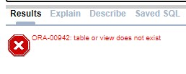

### From Fahad: =>

Now go back to “**Zia**” Account and grant permissions to “**Fahad and Nida”** so that they view all records from **results** table.

Query:

(First Connect Zia Account in SQLPlus then run query written below)

**grant select on results to fahad, nida;**

1. Also Assign “**select, insert, update** and **delete”** permissions on “**Results** **table”** to teachers “**Arshad and Sara**”

Query:

(As above Zia account is connect, so you can run the below query)

**grant alter, delete, insert, select, update on results to arshad, sara;**

1. Now Login into “**Sara”** account and try to insert a row in Results table.

Query:

# Insert into zia.results(result_id, coursename, student_role_number, marks) values(5, Python', 4, 75);

1. Now Login into “**Arshad”** account and try to delete a record having **result_id of “3”** Results table.

Query:

**delete zia.results where result_id = 3;**

1. Delete user account of “**Khan**” also revoke all his permissions.

Query:

**Drop user Khan cascade;**